Lower Granite RSW Spillbay PIT-Detection System
Construction & Final Inspection Complete January 31, 2020, system and spillway fully operational.

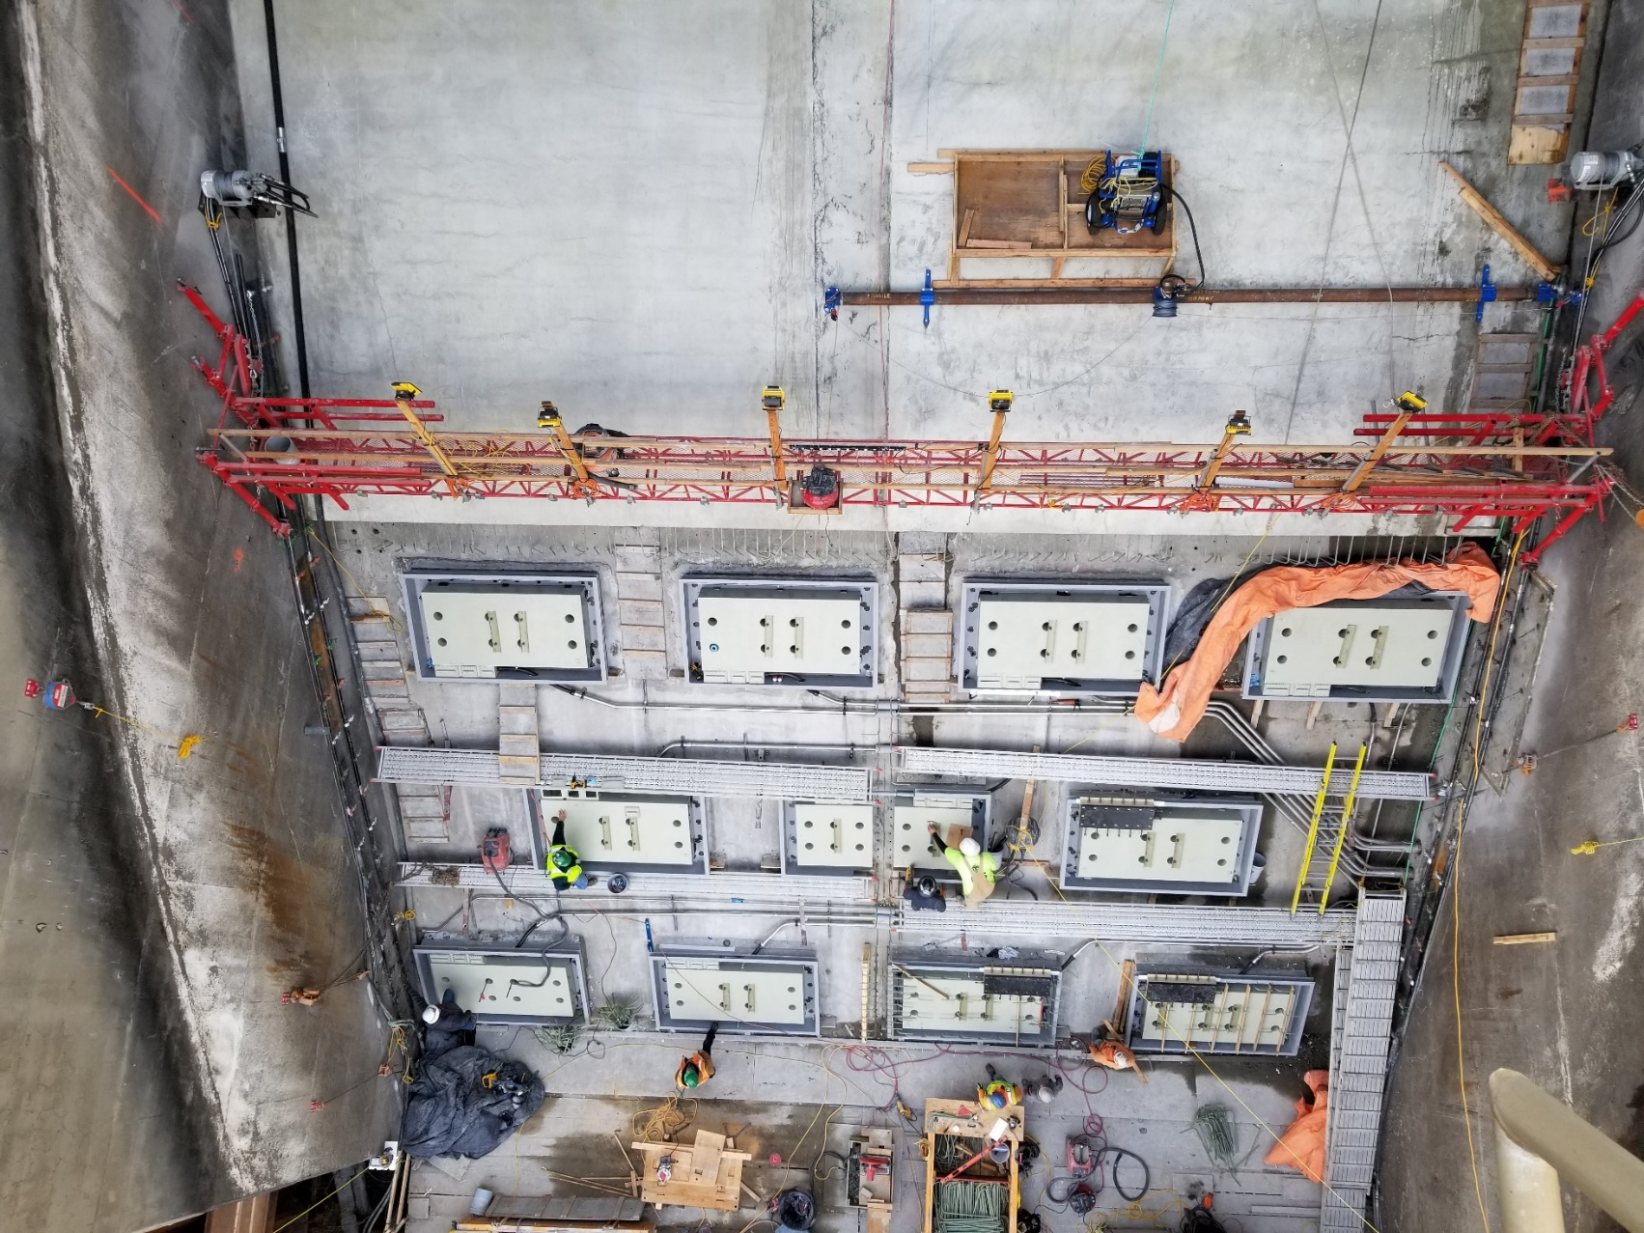
Figure 1. All 11 antennas installed on the ogee.

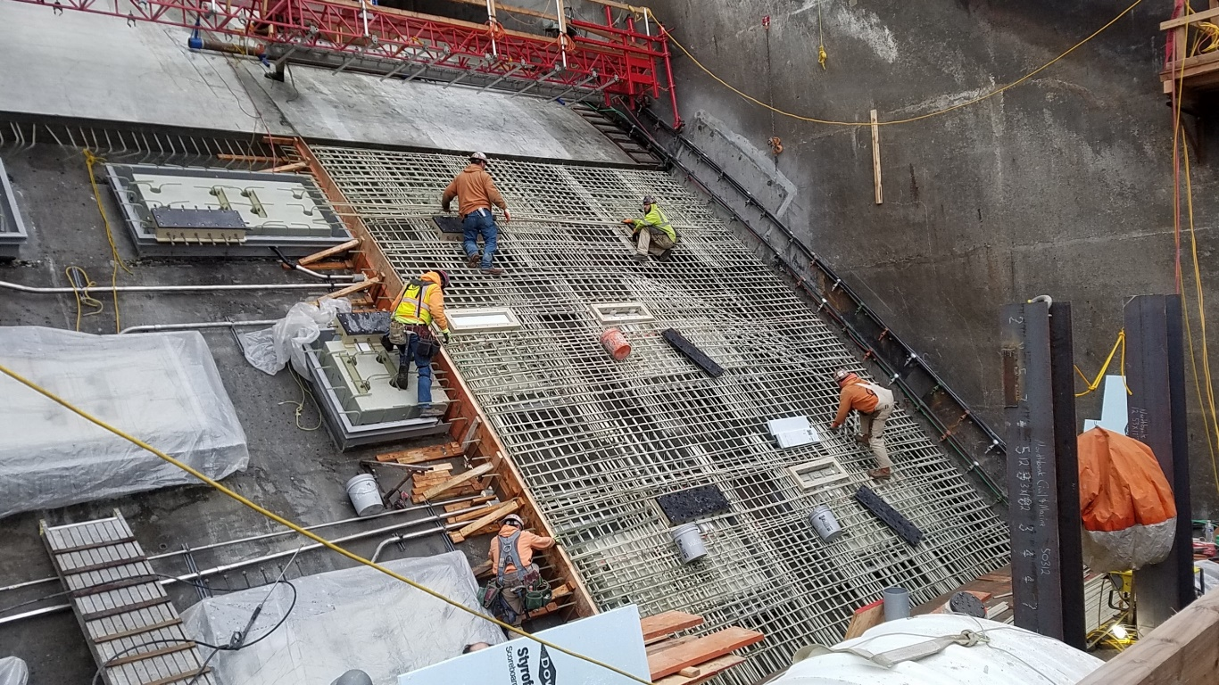
Figure 2. Fiberglass rebar being installed.
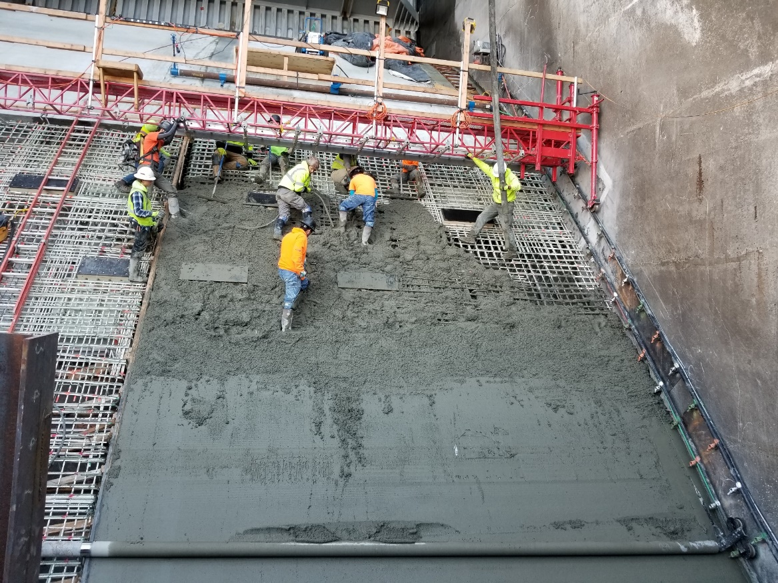
Figure 3. Concrete pour south half of antenna zone. In the bottom of the image is the roller which was used to smooth the concrete.

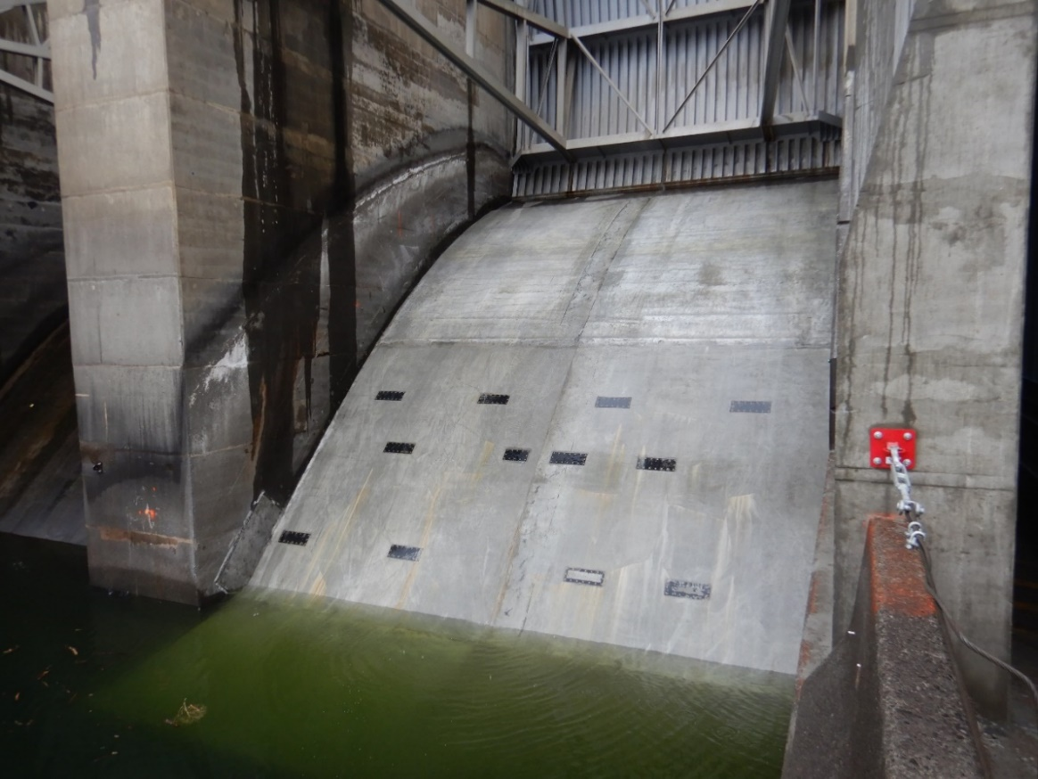
Figure 4. Finished Lower Granite RSW spillbay concrete. Antennas are approximately 7 inches below the concrete. The black rectangles are the capacitor box access UHMW lids.

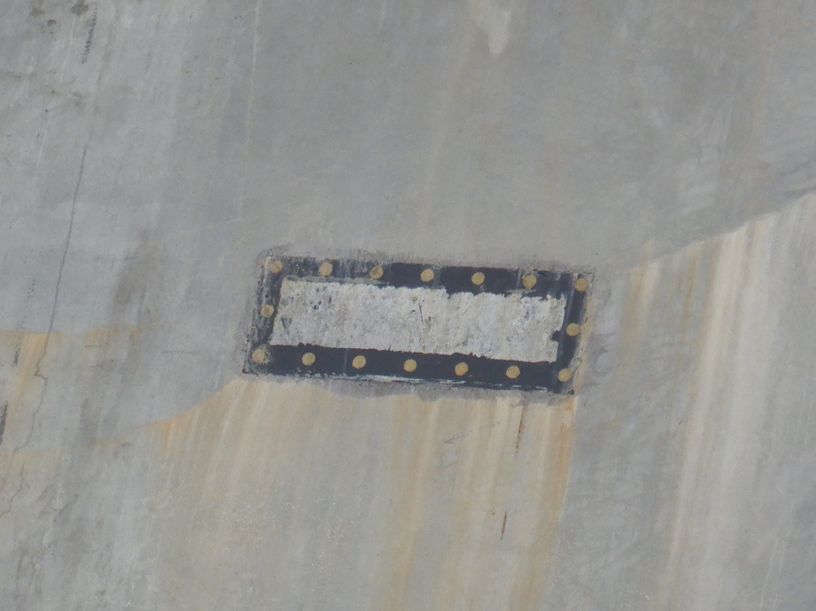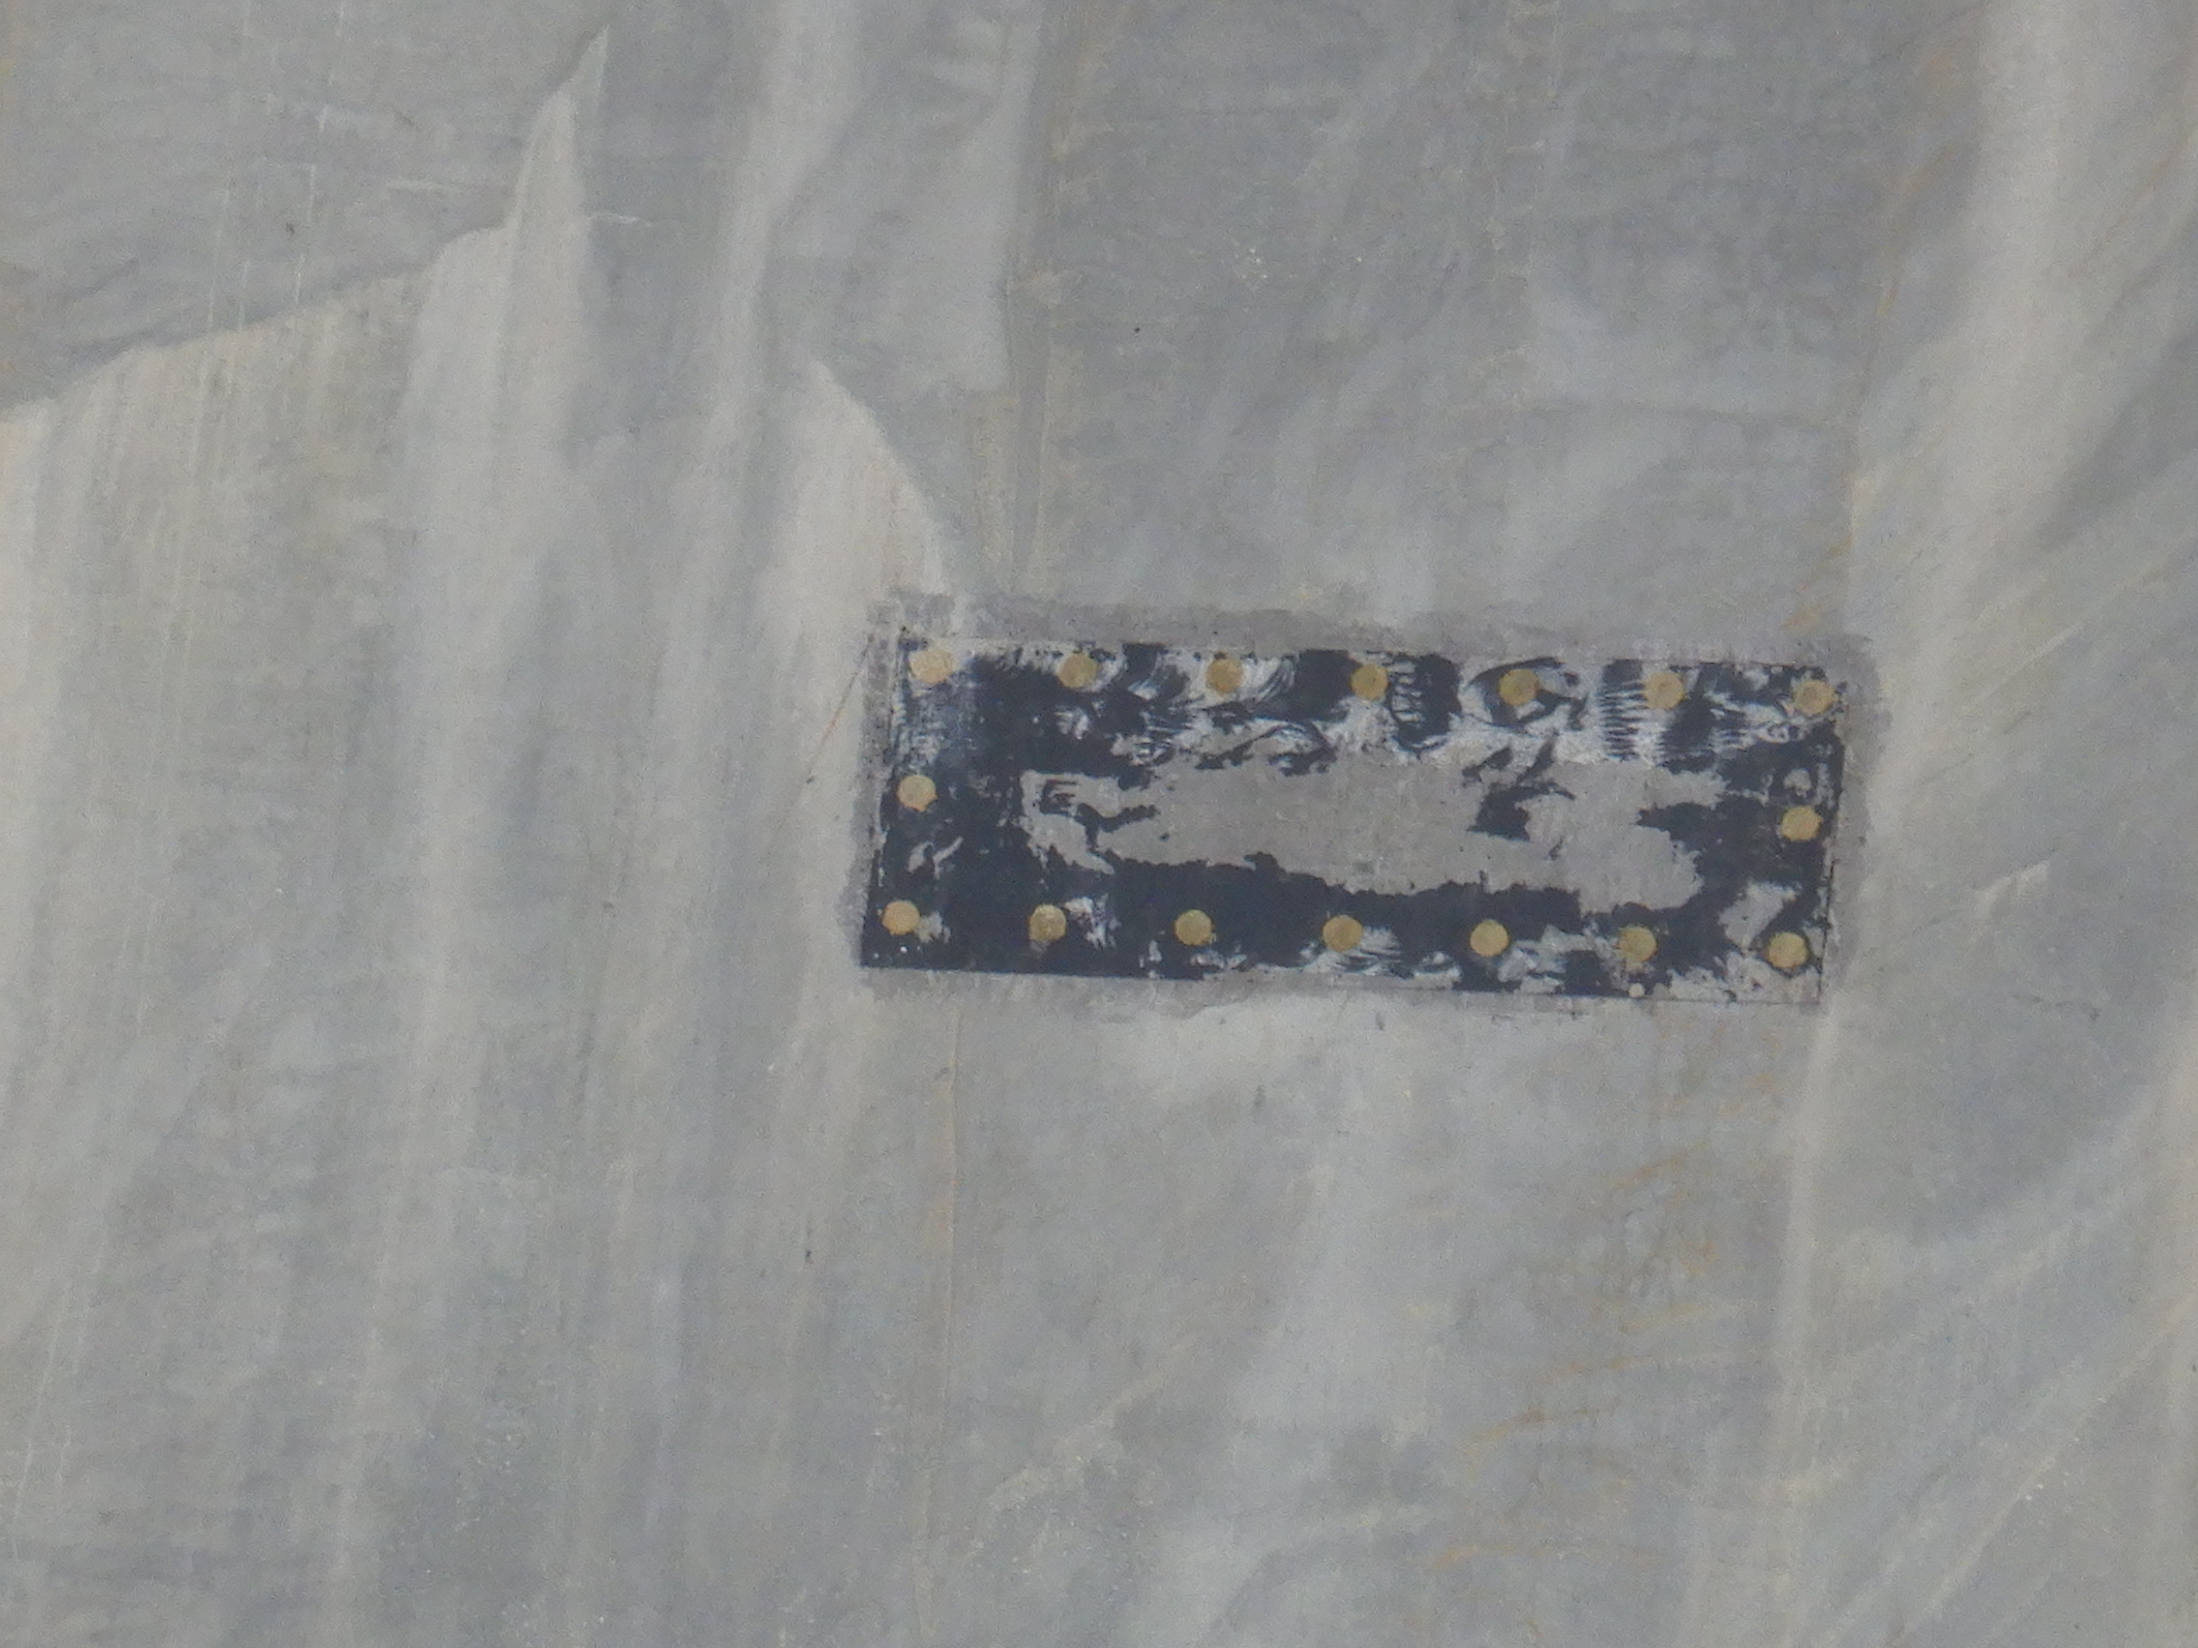
Figure 5. Capacitor lids with epoxy over the bolt heads.

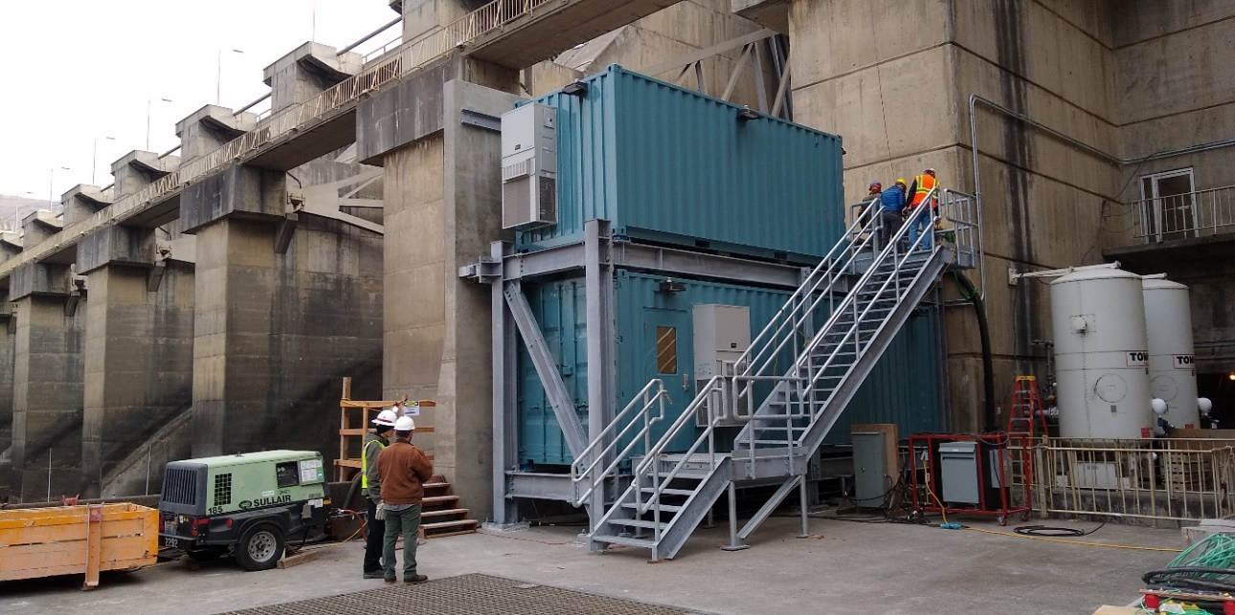
Figure 6. Transceiver Room for RSW Spillbay PIT-tag system.

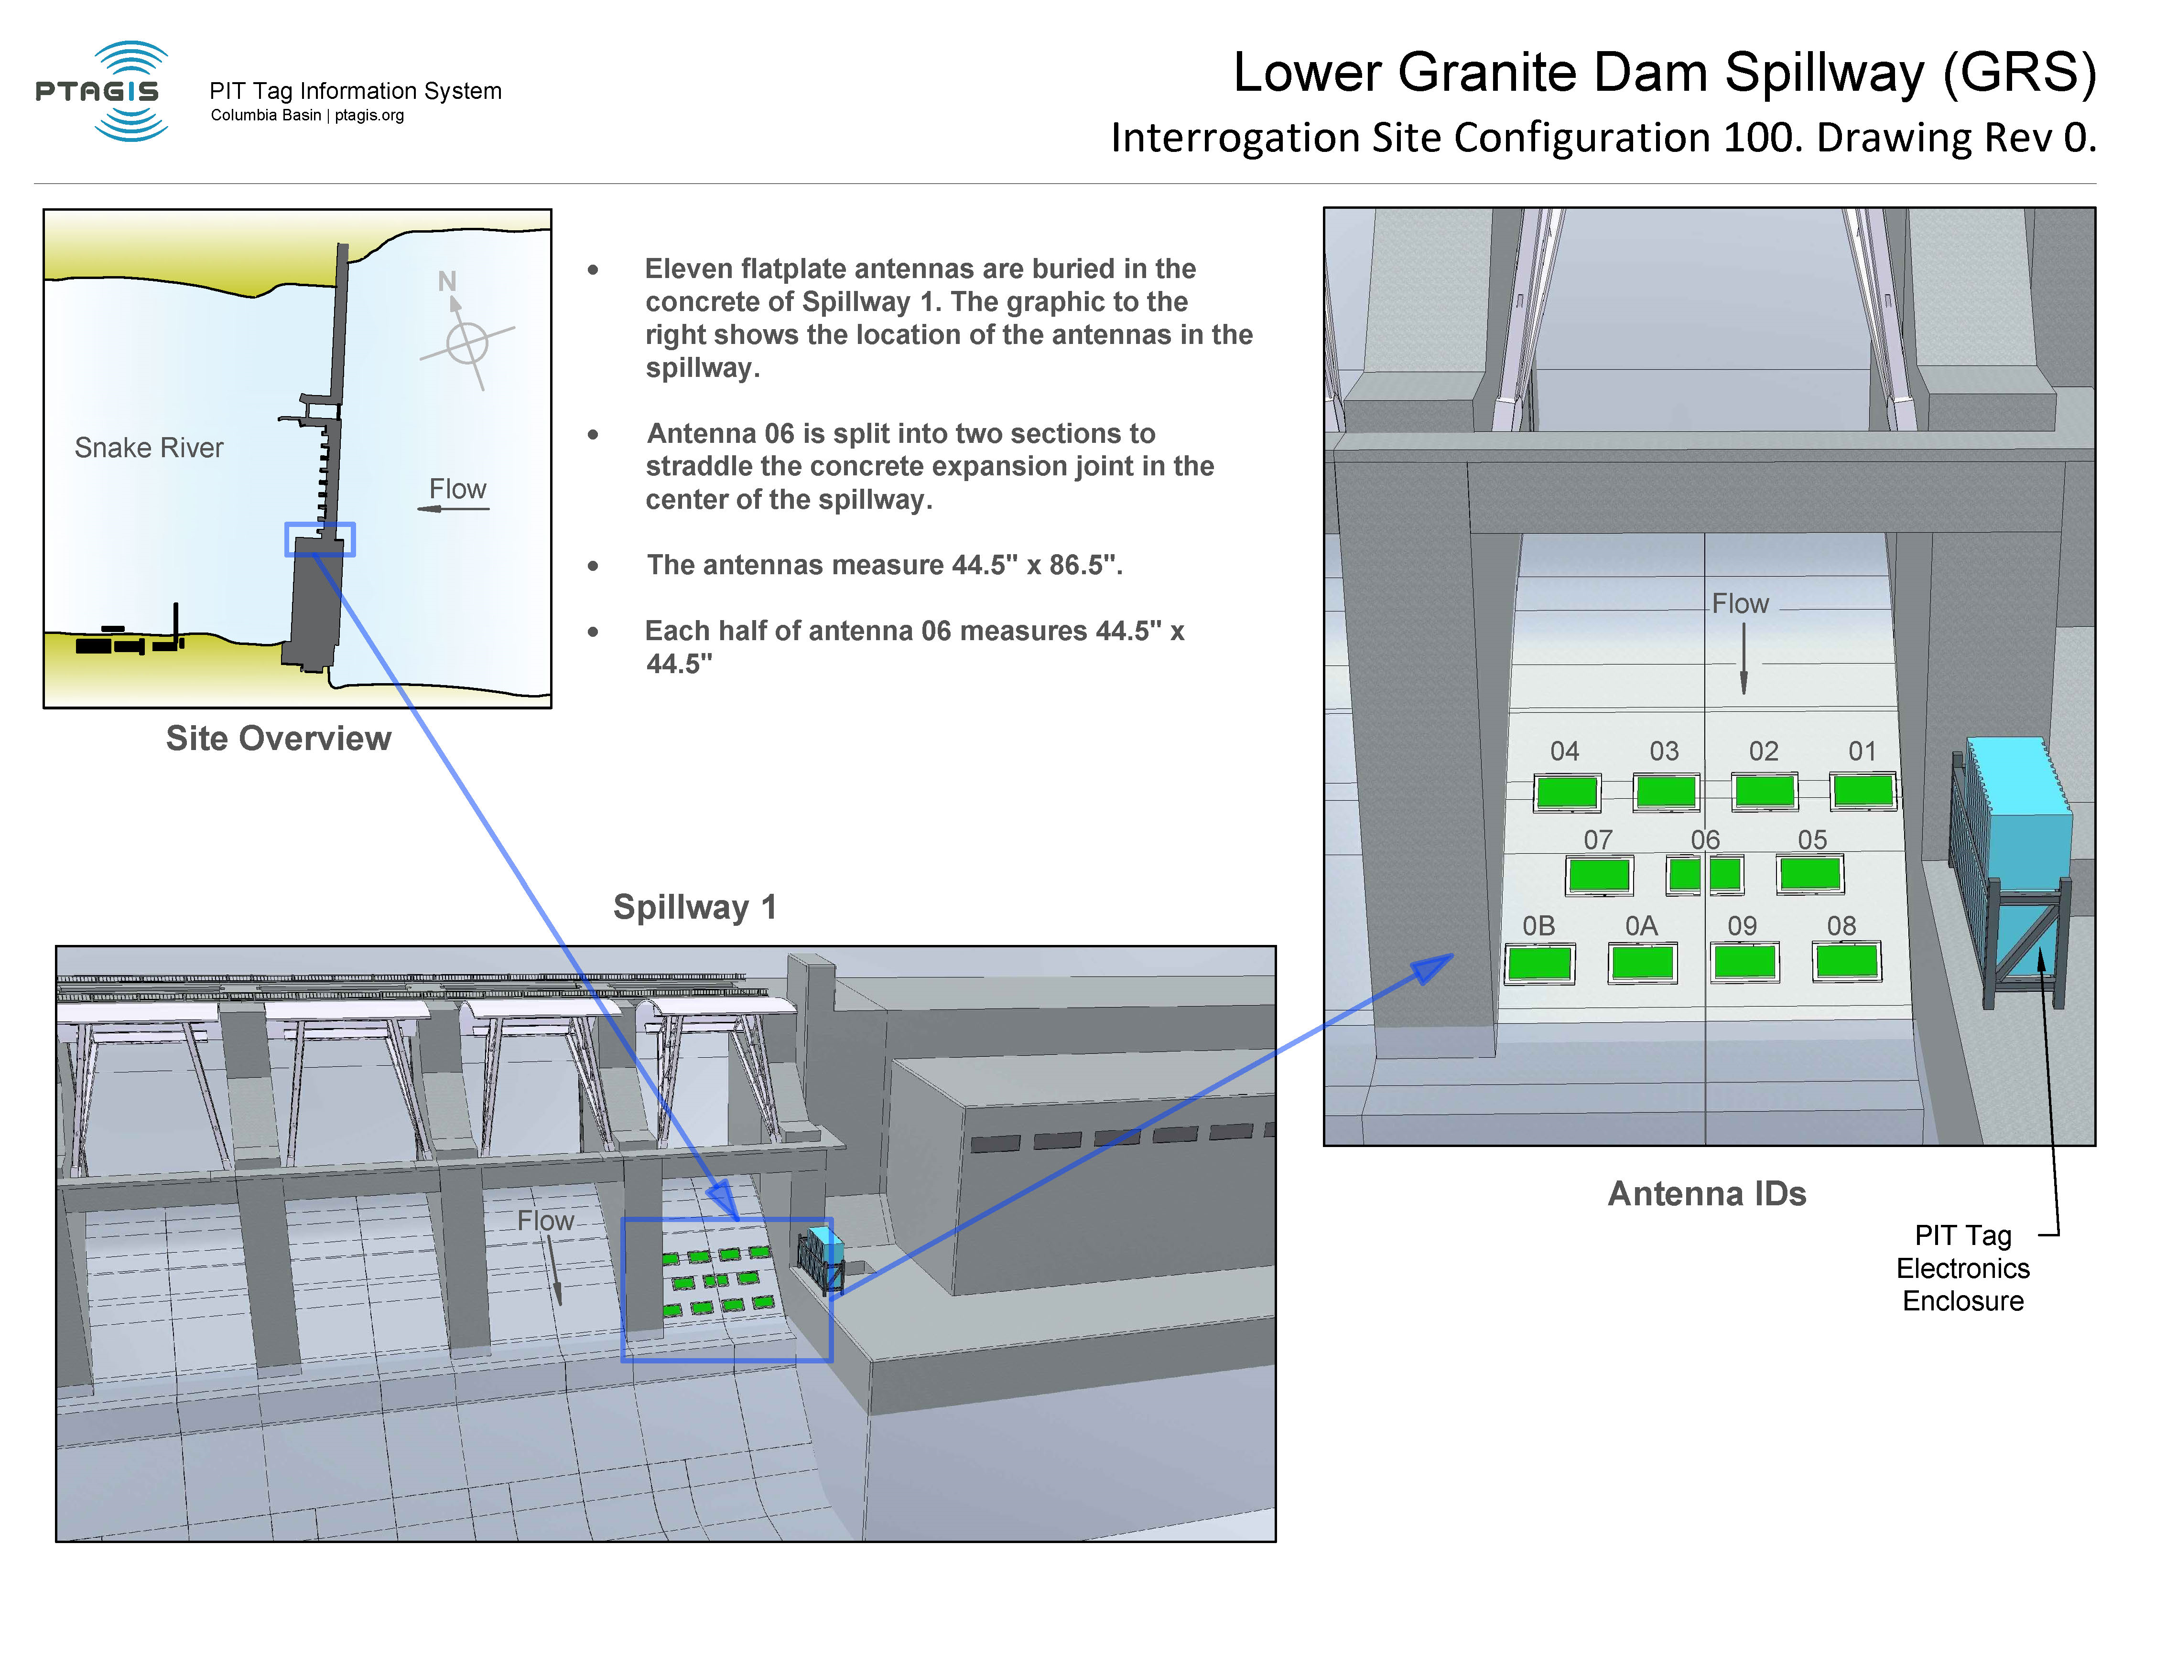
Figure 7. PTAGIS documentation of the site.

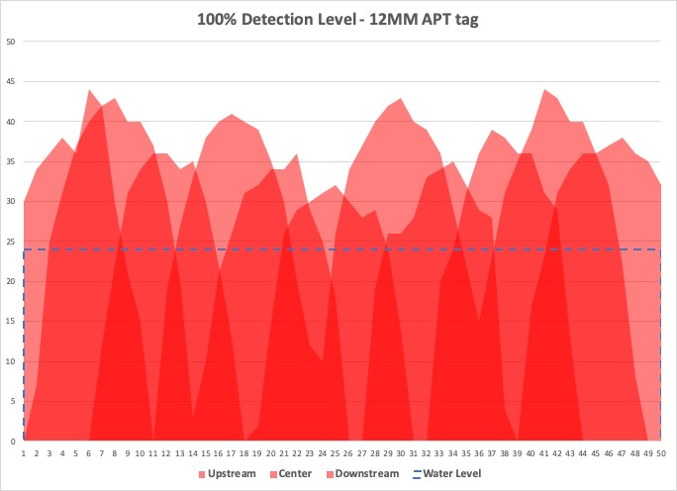
Figure 8. NOAA & PSMFC static detection field mapping after concrete placement. Y axis is depth (ft) and x axis is distance across the ogee. Darker colors indicate areas across the ogee with potential for detections on the various rows of the 3 rows of antennas. Water level is also shown.

Table 1. Lower Granite RSW spillbay PIT-tag detections during the 8-hour spill test on 26 January and 6-hour spill test on 28 January. Spill volume during the tests was 9.3 kcfs or approximately 30% more than normal (7 kcfs) due to forebay elevation. Estimated velocity during the spill test was 75.2 fps which was approximately 7% to 16% higher than normal (65 to 70 fps).

Tag Code | Species | Rear Type | Age | Release Site | Release Date | Reads | Antenna 1 | Antenna 2 | Obs Time | Spill Operation
3DD.00775A5EAE | Steelhead | Natural | Adult | LGRLDR | 10/8/2019 | 1 | 09 |  | 1/26/20 9:48 | 0900-1700
3DD.00778062E1 | Steelhead | Hatchery | Adult | LYFE | 4/17/2018 | 1 | 03 | 06 | 1/26/20 16:34 | 0900-1700
3DD.00775A1B59 | Steelhead | Natural | Adult | LGRLDR | 10/10/2019 | 1 | 06 |  | 1/28/20 10:23 | 1000-1600
3DD.00778CFCAE | Steelhead | Hatchery | Adult | LYFE | 4/17/2018 | 2 | 05 |  | 1/28/20 10:49 | 1000-1600
3DD.003D36476B | Steelhead | Unknown | Adult | BONAFF | 7/12/2019 | 2 | 03 | 0A | 1/28/20 10:52 | 1000-1600
3DD.0077B7CFB7 | Steelhead | Natural | Adult | JDARSF | 5/18/2017 | 2 | 02 | 09 | 1/28/20 14:30 | 1000-1600
3DD.007761CD4E | Steelhead | Natural | Adult | LGRLDR | 10/5/2019 | 2 | 07 | 0A | 1/28/20 14:48 | 1000-1600

NOAA is planning to evaluate detection efficiencies with fish releases in April 2020.

